LateralPaD-A surface-haptic device that produces lateral forces on a bare finger

【Summary】：

LateralPaD is a surface haptic device that generates lateral (shearing) force on bare fingers by vibrating the touch surface in both out-of-plane (normal) and in-plane (lateral) directions.

【LateralPaD】：

**Design principle:** Our LateralPaD prototype is a 22 mm x 76 mm x 2.3 mm glass plate driven by two sets of piezoelectric actuators (henceforth, “piezos”). Two piezo disks glued to the top surface of the glass excite a bending resonance for out-of-plane motion (Figure 3a), and piezo stacks at either end excite an in-plane resonance (Figure 3b). Out-of-plane motion will be referred to as “normal vibration” and in-plane motion will be referred to as “lateral vibration.” Figure 1 shows the LateralPaD on a 2DOF load cell setup. The whole structure is shown in Figure 2. In this figure, the light yellow rectangular region is the useful workspace where significant shear force can be developed. Finger position is measured with a projected capacitance sensor, visible as the green circuit board underneath the glass touch surface in Figure 1. (This sensor is not integrated to the glass, and is not transparent.)

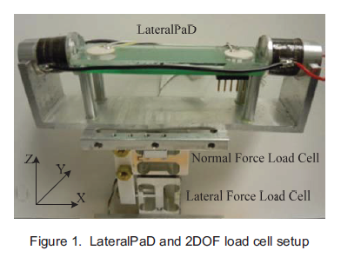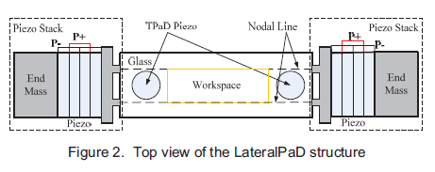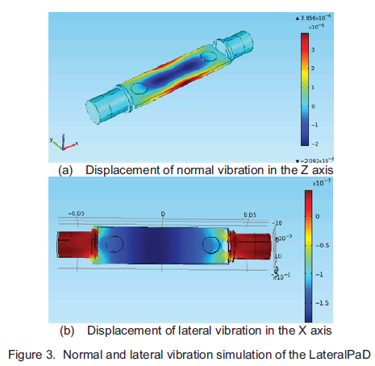

【Important Reference】:

[1] Margaret Diane Rezvan Minsky. Computational Haptics: The Sandpaper System for Synthesizing Texture fora Force-Feedback Display. PhD dissertation, Massachusetts Institute of Technology, 1995.

[2] Gabriel Robles-De-La-Torre & Vincent Hayward. Force can overcome object geometry in the perception of shape through active touch. Nature, Vol. 412, pp: 445-448, 2001.

[3] Masaya Takasaki, Hiroyuki Kotani, Takeshi Mizunoe, et.al. Transparent Surface Acoustic Wave Tactile Display. Proceedings of IEEE/RSJ International Conference on Intelligent Robots and

[8] OlivierBau, Ivan Poupyrev, Ali Israr, et al. Teslatouch: electrovibration for touch surfaces. Proceedings of the 23nd annual ACM symposium on User interface software and technology, New York, NY, USA 2010, pp. 283-292

[10] Erik C. Chubb, J. Edward Colgate, and Michael A. Peshkin. ShiverPaD: A Glass Haptic Surface That Produces Shear Force on a Bare Finger, IEEE Transactions on Haptics, Vol.3, No.3, pp: 189-198, 2010.